IT24101291  
PS_ Lab8

Q1)  
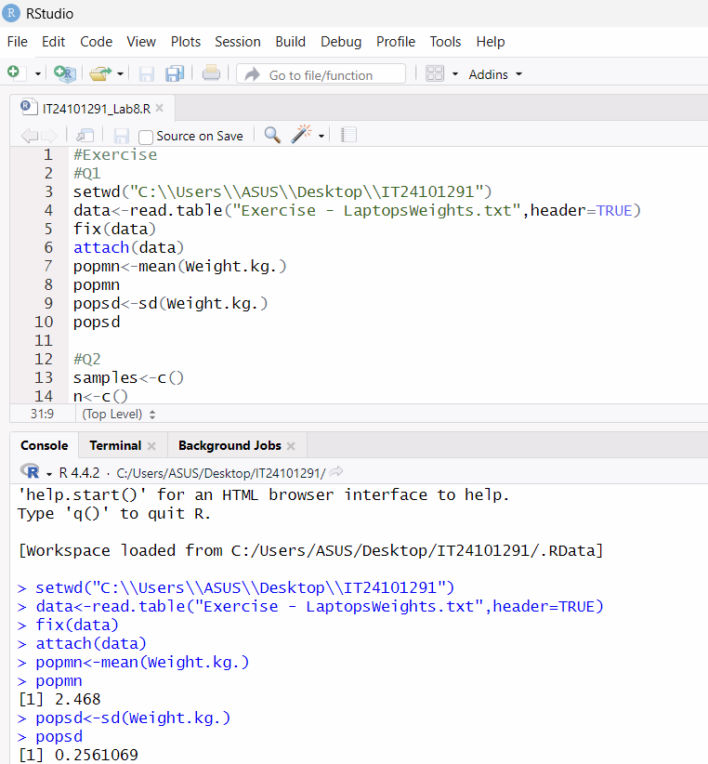

Q2)

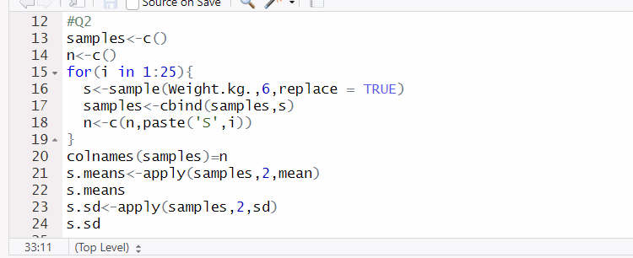Q3)